Crown says B.C. woman killed for marrying against family’s wishes

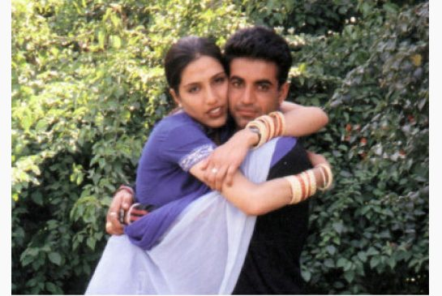
THE CANADIAN PRESS FILE PHOTO
Jassi Sidhu and her husband, Sukhwinder (Mithu) Sidhu, were attacked near a small village in the Punjab on June 8, 2000.
By: Dene Moore The Canadian Press, Published on Tue Jan 14 2014
VANCOUVER—A young British Columbia woman who authorities believe was murdered in a so-called honour killing feared for her life after her family found out about her secret marriage, a Crown lawyer said Monday at the extradition hearing of her mother and uncle.
The murder of Jaswinder “Jassi” Sidhu in India almost 14 years ago was motivated by her decision to marry against the wishes of her family, Deborah Strachan told the court on the first day of final arguments in the case.
The woman’s mother, Malkit Kaur Sidhu, and her uncle, Surjit Singh Badesha, face trial in India for conspiracy to commit murder in her death.
The conduct of the two accused amounted to “a systematic campaign of terror perpetrated by the persons sought against Jassi and Mithu in order to end their marriage and restore the family’s honour,” Strachan told B.C. Supreme Court Justice Gregory Fitch.
Jassi Sidhu and her husband, Sukhwinder (Mithu) Sidhu, were attacked near a small village in the Punjab on June 8, 2000. He survived but her body was found several days later.
During intermittent hearings over the past eight months, the judge heard testimony from Jassi Sidhu’s friends and co-workers about her life and her secret love.
Court heard that family members kept her under watch at school and at work, and on more than one occasion, police were called.
In February 2000, her family found out she had married a poor rickshaw driver in India and not the wealthy older man whom of their choice and the situation worsened.
“The evidence is clear, in our submission, that Jassi feared that her uncle would kill her if he ever found out about her relationship with Mithu,” Strachan said. “That fear intensified when the marriage was discovered.”
Court heard Badesha threatened to kill her and her husband if she didn’t sign a letter falsely claiming the marriage was forced upon her, Strachan reminded the judge and threatened her again over returning to India.
Jassi’s mother was also vehemently opposed to the union, Strachan said.
“In the tension-filled period between discovery of the marriage by the family and Jassi departing for India, Ms. Sidhu told Jassi she wished she had aborted her,” Strachan told the judge.
But she refused to disavow her husband, Strachan said.
“(Jassi) was determine to bring him to Canada to start a new life despite the wrath of her mother and uncle,” Strachan said.
Malkit Kaur Sidhu, who along with Badesha appeared via video link, wiped away tears as the lawyer for the federal Attorney General described her role on the crime.
Jassi Sidhu was 25 when her body was found in a canal a few days after the attack.
Several men have already been convicted of the crime in India and Strachan pointed out that there were more than 250 calls between Badesha and some of those men beginning immediately after the illicit marriage came to light. The calls peaked the day Jassi Sidhu was killed.
Court heard she was likely stabbed with a kirpan that her husband saw in the hands of one of the assailants, and probably the same bloodstained kirpan later found by police at the farm of one of the convicted men. Police also found a photo of Jassi Sidhu with her personal details written on the back, Strachan said.
The evidence against the mother and uncle is circumstantial, the Crown admitted, but enough to send them to India to face trial.
Final arguments are scheduled to continue over four days.
Michael Klein, Badesha’s lawyer, has yet to address the court but has told the judge that the passage of time and widespread coverage of the crime — which includes a movie based on her life and a book — makes witness testimony unreliable.
David Crossin, Sidhu’s lawyer, has suggested to the court in previous hearings that Jassi Sidhu’s mother faced the same authoritarian conditions in Badesha’s home as her daughter.

Article Overview
Jaswinder Sidhu a British Columbian was murdered 14 years ago in India. Deborah Strachan, Crown attorney, told the court that the murder was caused because Sidhu decided to marry against her parent's wishes. Her family wanted her to marry a "wealthy, older man" whereas she fell in love with a "poor rickshaw driver". Her mother, Malkit Kaur Sidhu and uncle Surjit Singh Badesha are facing charges for plotting her death. Her uncle had threatened to kill her if she did not sign letter that falsely claimed that she had been forced into marriage. She refused to do so. There is also evidence that there have been many phones, exactly 250, between her uncle and some mysterious men. When she was in India, Jaswinder and her husband were attacked in Punjab and her husband escaped but her body was found several days later. The courts have determined that she was stabbed with a kirpan (religious dagger). Sidhu's lawyer says that Jaswinder's mom had faced the same strict conditions in her uncle's house as her daughter.
Connections to Human Rights
Article 5 states that no one shall be subjected to torture and cruel treatment or punishment. Many of Jassi's co-workers stated that she complained of how her uncle would lock her in a room and would not let her out for days. From what is stated within the article, Jassi has not done anything wrong that deserves punishments as such. There is absolutely no need for her uncle to treat her in such a degrading way.
Article 1 is also being violated, it says all are born equal and free and have the right to make their own decisions. This is being violated because her family is not allowing her to marry the man of her wishes or live the life she wants. They force her to live her life their way and marry the person they want.
Article 3 is being violated, it mentions that everyone has the right to life, liberty and security of person. Jassi said she did not feel safe in her own household because her uncle was so strict. After marrying the man of her choosing she became even more frightened because she predicted her uncle might kill her and her husband because he was strictly against it.

Work Cited
Moore, Dene. "Crown Says B.C. Woman Killed for Marrying against Family's Wishes."Thestar.com. N.p., 14 Jan. 2014. Web. 05 Apr. 2014.
http://www.thestar.com/news/canada/2014/01/14/crown_says_bc_woman_killed_for_ma rrying_against_familys_wishes.html

